**CCT College Dublin**

**Assessment Cover Page**

|  |  |
| --- | --- |
| **Module Title:** | Time and Task Management |
| **Assessment Title:** | CA 2 – Final Report Formation of an IT Consultancy company |
| **Lecturer Name:** | James Garza |
| **Students Full Name:** | Kevin Esteff, Fernanda de Souza, Heloisa Eugenio |
| **Student Numbers:** | 2023286, 2023223, 2023264 |
| **Assessment Due Date:** | 28th November 2023 |
| **Date of Submission:** | 28th November 2023 |

**Declaration**

|  |
| --- |
| By submitting this assessment, I confirm that I have read the CCT policy on Academic Misconduct and understand the implications of submitting work that is not my own or does not appropriately reference material taken from a third party or other source. I declare it to be my own work and that all material from third parties has been appropriately referenced. I further confirm that this work has not previously been submitted for assessment by myself or someone else in CCT College Dublin or any other higher education institution. |

11/28/2023

Kevin, Fernanda, Heloisa

STOCKTRACK

Time & Task Management

CA2: IT – CONSULTANT

Contents

Introduction 4

Main purpose 4

Structure of the company 4

Culture of the company 4

SWOT 4

Planning process 4

Brief of the project 4

Main goal of the project & Milestones 4

Initial plan – Gantt Chart and Explanation 5

Planning process with tasks depending on leader Feedback. 6

Revised plan – Explanation of changes + Gant Cart updated. 6

Research and Development Department Documents 7

Market Analysis 7

Research 7

Sales & Marketing Department Documents 11

Website design 11

Post Calendar and posts 12

Performance evaluation 14

Brainstorming 16

Self Reflection 16

**Heloisa** 16

References 17

Figure

# **Introduction**

Stock track was created to meets innovation to redefine a business operation. The company with a mission to empower business, operates deeply in hospitality industry, in their day to day. The company specializes in creating a innovation software solutions and tools tailoring to meet the unique challenges and demands of hospitality environment.

**Meet the Team members**

**Kevin** - Management, Planning process, and Gannt chart.

**Fernanda** - Research & Development, main purpose introduction, and analysing the final project.

**Heloisa** - Sales & Marketing, Development process.

## **Main purpose**

The main purpose of the Stock track is to help businesses in the hospitality industry in efficient management in their inventory, purchasing, and cost control. Follow below the primary purpose of Stock Track:

**Inventory management**: stock track helps businesses to keep track all the inventory levels in the real time by integrating the stock track into other systems that company already use (like touchbistro and clover) so them they communicate between them and give the right stoke Sales, also allowed to monitor stock quantities, manager reorder points, and preventing overstocking and understocking of essential items.

**Cost control**: Stock Track assists a company in monitoring their sales, product cost identifying and reducing business expenses. By doing so, it enables companies to increase profit and maintain control over their profit margins.

**Purchase and order management**: Stock Track Streamlines purchase by establishing seamless communication with the supplier. This eliminates the need for manual order placement, allowing your management team to save time and effortlessly initiate orders directly through the application so who is managing the place don’t waste time to do the order and do it easier using the and ordering from there, also the app check and notify the manager with the missing items from the inventory so assists the management time.  
The app operates as a vigilant inventory, notifying the manager about the any low stock items. The system enhances proactive and positive management by ensuring if the essential item is always in stock.

**Recipe management**: Stock track is behind of the menus and pricing dealing with the cost management together with the inputs recipes making the company a part in what is going on with their company also all the staff to be able to perform the same recipe for each product like that ensuring all the company consistency in terms of stock, recipe product, and manager satisfaction.

**Vendor management**: Stock Track organize and maintain Database of their suppliers and track relevant information’s as collections of payment terms, historical data, and contacts (as the suppliers).

**Reporting and analytics**: Stock Track Offers the accountants from the business full logistic management of the inventory, order, and cost. The accountant or business owner has now a full website generated reports on inventory levels, purchasing historical, and financial performance. In this way this allow to the company members to be always aware of their company.

**Mobile accessibility**: Stock track also provide mobile app making accessible for everyone to use in their venue, allowing them to check the inventory Items, do the order, and manage cost. This app flexibility is very useful for the Stocktaking and management when they need to do an update.

## **Structure of the company**

Stock track’s structure aligns with its mission to increase business providing a cutting-edge solutions, operations, and sustainable growth. Through it is diverse features and dedicated team, Stock track stands as a leader in the realm of innovative software solutions for the hospitality industry.

## **Culture of the company**

At Stock track, our company culture is the heart that is the brain of the drivers our innovation and success in the dynamic landscape of the hospitality sector. Rooted in value that prioritize excellence, collaboration, and adaptability, our culture reflects the vibrant and forward-thinking team that defines Stock Track. It is no just a set of principles on paper; it’s the living, is the essence that guides our actions, increase the passion toward a future of continued innovation and success in the hospitality technology landscape.

## **SWOT**

**Strengths**

The main strength of our inventory control lies in our technologically advanced and intuitive platform. We have developed a powerful system that offers efficient food and beverage tracking, giving restaurants a clear, real-time view of their inventory. Additionally, our dedicated team offers expert technical support, ensuring customers can make the most of our solution. Operational efficiency and the ability to make informed decisions are, without a doubt, our distinctive strengths.

**Weaknesses**

Even with our strengths, we recognize that resistance to the adoption of new technologies by some establishments may represent a potential weakness. Reliance on internet connectivity can also be a challenge, especially in regions where infrastructure is less developed. Furthermore, the learning curve associated with implementing new system may be perceived as a barrier for some users, requiring additional efforts in education and training.

**Opportunities**

The restaurant inventory control market presents significant opportunities for expansion. Growing awareness about operational efficiency and waste reduction in the food sector opens doors to strategic partnerships with restaurants of different sizes. Additionally, continually customizing our software to meet specific customer needs can position us as an innovative leader in the market, enabling the development of new features and functionality.

**Threats**

Among the threats we face, the competition in the restaurant technology sector is a crucial consideration. Other challenges include volatility in food input prices and dependence on third-party suppliers. Changes in government regulation also pose a threat, requiring us to be agile to adapt to any changes in the regulatory environment that may impact our operations and market demand.

# **Planning process**

## **Brief of the project**

The Stock Track is a cloud-based platform that supports businesses of various sizes with procurement, stock delivery monitoring, and financial management. Its essential components encompass menu cloud Information, financial planning, supplier coordination and automated order recommendations.

## **Main goal of the project & Milestones**

Establishing company goals provides your team members something to work for and your corporation a direction. Without objectives, the organisation won’t have a clear sense of direction and may even be prevented from achieving the accomplishments it would otherwise have.

In the coming year, our business is committed to achieving several key goals and milestones. First and foremost, we aim to have an average customer base through targeted marketing and outreach initiatives, and in the coming months, focus on increasing the number of customers. Additionally, we will focus on enhancing our product line with the introduction of two new innovative offerings, scheduled for release until the end of the year. Lastly, we will prioritize operational efficiency by implementing cost-saving measures that aim to increase our profit margins by 15% over the next 12 months. There goals and milestones represent our dedication to growth, innovation, and financial sustainability as we continue to thrive in the competitive market.

## **Initial plan – Gantt Chart and Explanation**

Figure

We created a poll ourselves and decided what each person would work on, making it more comfortable to talk about the topics.

Within 20 days to have the 1st checkpoint done, we couldn’t have more than 5 days for each topic, or we would be late to upload the file, so we did well manage our time.

Our Gantt Chart contains all the group members, all their responsibilities with the timelines and deadlines until the 22nd of October, how everyone’s working on the project and it’s very easy to see and track.

## **Planning process with tasks depending on leader Feedback.**

Kevin as a leader chose a proactive delegation approach. When defining tasks, he considers the individual skills of each team member, distributing responsibilities according to their skills. His style is characterized by clear instructions and setting realistic deadlines. He encourages autonomy by allowing team members to take responsibility for their tasks.

Fernanda demonstrated remarkable skill in leading innovative initiatives and applying a proactive approach to app development. Her tireless dedication and in-depth technical knowledge were essential to the success of this project. The quality of the application directly reflects Fernanda’s professionalism and expertise. We are incredibly grateful to have her as a leader in the field of research and development.

Heloisa demonstrated a unique strategic vision by creating an engaging website that accurately reflects our company’s identity. Her ability to manage the social media was notable, contributing to greater visibility and interaction with our target audience. Her attention to detail and creativity were fundamental to the success of these marketing initiatives.

## **Revised plan – Explanation of changes + Gant Cart updated.**

Figure

Based on the feedback received for the first checkpoint CA 1, we identified gaps in the information provided and, as a result, implemented significant improvements to the report. We incorporated additional details that were initially missing.

These additions not only met the expectations in the feedback, but also contributed to a more robust second checkpoint update. Additionally, we took the opportunity to update the second Gantt Chart, adding important tasks and defining clearer deadlines. This improved scheduling strategy show our dedication to effective project management and gives a more realist picture of upcoming milestones.

# **Research and Development Department Documents**

## **Market Analysis**

Google form

<https://forms.gle/C9Hrs69vyrXUMU4g8>

## **Research**

**Software for Inventory Management**

For effective operations, selecting the appropriate inventory management software is essential. Looking for systems that offer sophisticated capabilities as automated reorder point and thorough inventory reporting, in addition to real-time tracking. Examine the software’s flexibility to make sure it can adjust to the project’s changing requirements. To establish a smooth process, take into account integration possibilities with other products as well.

**Purchasing and Procurement Tools**

Finding software solutions with more features than just basic functionality is crucial in the field of purchasing and procurement. Look for solutions that can help you with every step of the procurement process. From creating orders to managing venders. Features for electronic ordering may cut down on manual labour considerably, and strong vendor management makes teamwork easier. Examine the possibility of customising the program to match certain project needs.

**Cost Control and Analysis Software**

When looking for a software for cost control and analysis, pay particular attention to programs that provide comprehensive cost monitoring and analysis. Search for characteristics that support strategic decision-making by offering a comprehensive perspective of financial measures. Versatility is essential to support the project’s expansion, and the software should make it simple for team members to collaborate while performing financial analysis.

**Recipe Management Applications**

A crucial component is recipe management, particularly for initiatives involving the food and beverage sector. Find programs that provide extensive recipe management features. Accurate financial planning is assisted by features like automated cost estimation depending on constituent costs. Make sure the program allows for version control in recipes and easily connects with other programs to create a cohesive workflow.

**Systems for managing vendors.**

A flawless supply chain requires efficient vender management. Look at vendor management solutions with strong organisational features. Seek for elements that’s facilitate the methodical service and arrangement of a supplier database. Processes for negotiation and decision-making may be improved by keeping track of vendor details, terms, and historical data

**Reporting and Analytics Tools**

Tools for analytics and reporting are essential for obtaining insights that can be put into practice. Analise programs with plenty of capabilities for producing reports that are insightful. Think about using technologies that provide sophisticated analytics in addition to traditional reporting to have a better knowledge of purchase patterns, inventory levels, financial performance. Options for customization guarantee that the reports produced correspond with certain project metrics.

**Mobile Accessibility**

In today’s dynamic business environment, mobile accessibility is crucial. Chose software programs that have mobile applications so that team members may purchase, manage inventory, and keep an eye on expenses while they’re on the road. Decision-making in real time and increased productivity are facilitated by an intuitive mobile interface.

**Integration Capabilities**

Check how well the chosen software integrates with the other systems being utilized for the project. Reducing the need for manual data entry and ensuring a unified workflow are two benefits of seamless connection with current tools or platforms. Enhanced overall efficiency is achieved through compatibility with popular project management or accounting applications.

**User Interface and Experience**

The experience and user interface of any product are essential components in its effective adoption. Consider how intuitive and user-friendly possible solutions are. A well-designed interface helps team members acquire new skills more quickly, which boosts output overall.

**Customer Reviews and References**

Customer reviews and feedbacks provide valuable insight into the real-world performance of the software. Look into and get opinions from companies that have used the software solutions that have been identified. Take into account the suggestions and experiences of users in related businesses, since these might provide real-world insights on the efficacy of the program.

**Budget and Cost Considerations**

Evaluating the software solutions’ price structures is crucial to ensuring that the project stays within financial limits. Consider the upfront expenses as well as any possible recurring fees. Make sure the software fits the project’s financial limitations while taking into account its long-term utility.

# **Sales & Marketing Department Documents**

## **Website design**

The task was to create a wireframe from the homepage for the company and post 3 pictures on social media, apart from this it was discussed and decided in the group how would look the homepage, the process wasn't long it took at least 1 day to get the final project.

However, everyone in the group had a different expectation about how the homepage would be, so the only way to everyone agree would be to give as many ideas as possible and talk about which one was better for the creation of the homepage.

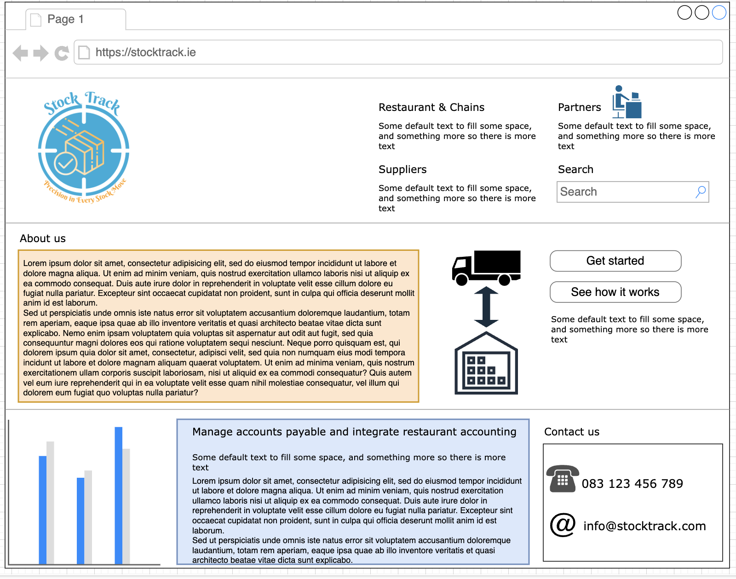

Figure

## **Post Calendar and posts**

Social media calendar

Figure

Social media is an important part of the marketing for all company, through social media customers can interact with, and always be updated. For the company to be successful having social media is extremely relevant and indispensable, so also apart from that the social media chosen for our company was Instagram because is easy to use and edit, for the customers know that is our account, the name for login was also (StockTrack) and most of the post would be analytics, checking costs, improvement, and giving advice about food and drink waste.

Figure

Figure 6

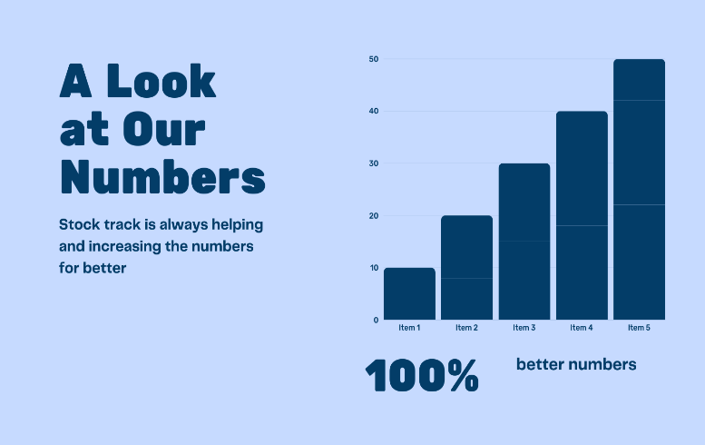

Figure 7

Show the customers the improvement on every stock such.

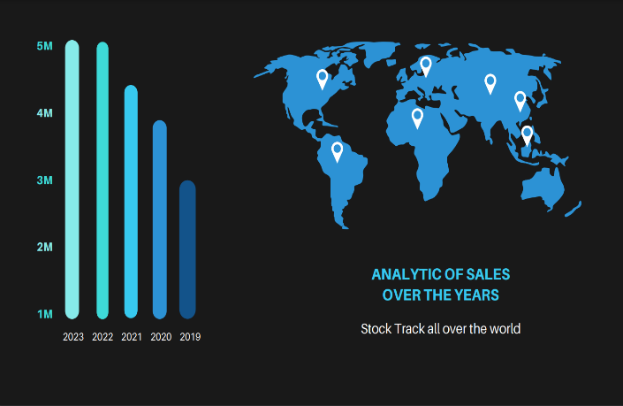Every year Stock Track is increasing and growing in which country, the customers can have access to our company whenever they are located. Since 2023 our company is getting better and bigger.

Figure 8

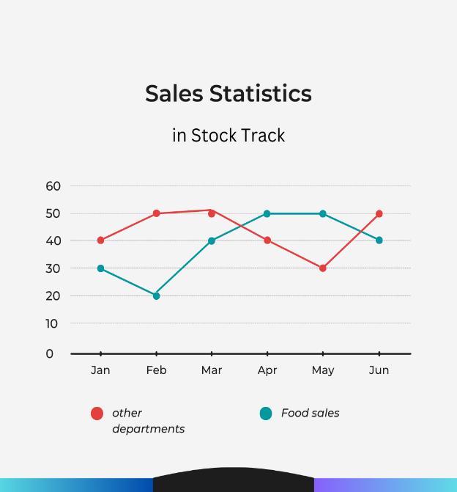

Figure 9

On this graphic, the customers can see the improvement in every department such as food sales and other departments.

**Conclusion**

In summary, an integrated approach from Management, Research and Development, and Sales and Marketing departments forms the operational basis of the IT company focused on inventory management control. Effective task assignment, proactive review and transparent communication in the Management Department lays a foundation for agile management. Meanwhile, the Research and Development Department, by creating tools for market analysis and prototyping solutions, drives innovation. The Sales and Marketing Department, by developing the wireframe website and social media strategies, increases visibility and connection with the public, consolidating the company’s position as a leader in the industry.

# **Performance evaluation**

|  |  |  |  |  |  |
| --- | --- | --- | --- | --- | --- |
| Student Name | Performance in their particular section (0-5) | Observations | Team-Work  (0-5) | Observations | Examiner Name |
| Fernanda | 5 | Did a good job in her particular tasks | 5 | Great ideas about the whole project and slides | Kevin |
| Kevin | 5 | Well managed with good gap between the deadlines and no pressure during the researches. | 5 | Gave important hints how we could work in our particular tasks | Heloisa |
| Heloisa | 5 | Well-designed wireframe website and social media posts. | 5 | Helped the group with ideas and researches. | Fernanda |

**Developing process**

The process of the logo was simple and clear, the initial idea was to design a box in the centre to give total relevance and meaning to the name of the company. Also, colours blue and white have been in the mind since the beginning, the fact the company wants to represent trust, loyalty and simplicity for our customers.

To get the final logo we had 2 attempts before, however, there weren't many differences between the original, it was just decided to add a slogan to give emphasis and change the colour of the box in the centre and of the text for orange mean confidence.

In addition to that the name was chosen to give context to our logo, the final logo has something that looks like an aim, and the thought was to show that the company are tracking every stock move.

Figure 10

## **Brainstorming**

The company goal is the growth in the industry and reach a very good number of customers. We decided to bring new Stock control to the industry, related to the companies in general including restaurant, bar, hardware shops, etc.

The idea of this project is to work directly with company’s stock getting ideas with every person from the group.

Our manager department and the other departments sections were decided in a meeting after class.

# **Self Reflection**

### **Heloisa**

Working in a group sometimes can be pretty difficult because of the fact many people with many different opinions, however, this CA was a good exercise to improve my group skills, and one of the reasons it made the homework much easier was everyone in the group have the same nationality and speak same mother language.

The CA, in general, wasn't hard, I guess the difficult part was agreeing with everyone in the group and having to discuss everything. The skill I had to solve problems was to talk about any problem and try to make a deal with my partners

### **Kevin**

Participating in group work with three people was initially challenging, as I had never faced this dynamic before. The experience was enriching, providing learning and growth. Overcoming initial difficulties allowed me to develop collaboration and communication skills, providing a valuable basis for future teamwork.

### **Fernanda**

Doing the IT consultancy CA was challenging, but collaborating with Kevin and Heloisa made the experience easier. The exchange of ideas was fluid, and I felt comfortable sharing my thoughts. Effective partnership not only facilitated the process but also enriched the work. I learned the importance of collaboration and how a cohesive team can overcome academic obstacles, transforming challenges into opportunities for personal and professional growth.

## **References**

www.bench.co. (n.d.). *10 Company Milestones to Aim for in Your First Year*. [online] Available at: https://www.bench.co/blog/starting-a-business/company-milestones.

‌MarketMan. (n.d.). *MarketMan: Restaurant Management Software (Free Demo)*. [online] Available at: https://www.marketman.com/.